Week In Review: August 24 - 30, 2001
Alex Shvartsman

Grand Prix-Santiago
The first-ever Grand Prix to be held in the South American country of Chile gathered just over 300 competitors. Both Americas were well represented with players traveling from United States, Mexico, Brazil, Uruguay, and Argentina.
Some of the high-profile pro players to show up in Santiago included international Grand Prix veterans Bob Maher, Brock Parker, Brian Davis, and David Williams. Some top-notch players who are not often found attending Grand Prix outside of United States were present - such as Alan Comer and William "Baby Huey" Jensen. Uruguay's Scott Richards who is invited to the Magic Invitational this autumn was on hand, as well as last year's invitee Gerardo Godinez of Mexico.
It was not a great tournament for the pros. Several of us failed to make Day 2 outright (Davis and myself included), while Williams, Comer, and Maher posted poor Day 2 performances to finish out of the money. Most of the pros felt that they chose to play the wrong decks by the end of the weekend. Maher, Jensen and Davis played Brian Kibler's version of Domain, and all regretted it. Comer and I played u-r-w Trenches and also felt that the deck was just not as good as our limited testing suggested. The only pros to succeed were Brock Parker, and Gerardo Godinez, who was embattled by accusations of unscrupulous play this weekend and even received a game loss for slow play.

The title went to Argentina's Matias Gabrenja, who used a b-g-r deck to defeat Godinez's b-r-u control deck in the finals. Gabrenja has earned the largest cash purse ever to be awarded at a Grand Prix as he won both first place and the top Amateur prize (money awarded to top finishers with no pro points). Gordon Lim at GP-Sydney previously accomplished this feat, but prize funds have been increased since then, allowing Gabrenja to break Lim's record.
Other Magic celebrities on hand included Randy Buehler, who spent the weekend gunslinging against the eager local players, and Adrian Sullivan who was in charge of Sideboard's coverage of the tournament.

Coming Up: Grand Prix-London and Singapore
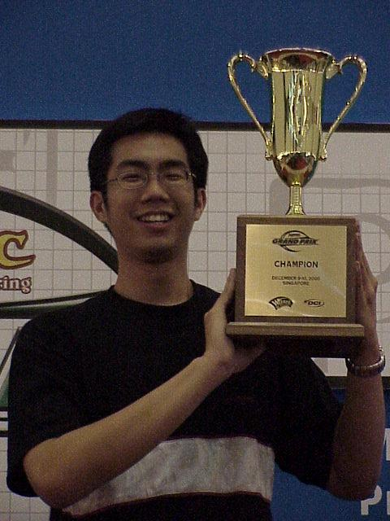
Can Sam Lau win another GP-Singapore?
European players are studying the worldwide metagame to prepare for the first IBC Grand Prix on their continent. The organizers are cautiously optimistic - a year ago, Grand Prix-Manchester failed to gather a large enough group of local players. GP-London is held at the site of Gen Con: UK and has been well promoted besides - so it should post greater numbers. Although Pro Tour-New York is just a week away, few pros are willing to skip this Grand Prix in order to get more Team Limited practice. Many have set up their itineraries to travel straight from London to New York on Monday.
After a Godzilla-sized GP Kobe, GP Singapore will certainly seem small by comparison. I would guess at about 200-250 players showing up for this one, and it will be interesting to see if any pros will brave the long flight so close to the Pro Tour - especially the Japanese pros who historically have dominated the Asian Grand Prix scene. Top local players Albertus Law and Nick Wong will certainly be there, seeking to add another accolade to their resumes.

Magic Invitational: The Ballots Are In

I'd like to thank all of those who voted for me.
Over 4000 have voted on The Sideboard web page, and they wish to see Dave Price, Gary Wise, Chris Pikula and Brian Kibler at the Magic Invitational. They edged out Ben Rubin, myself, and Darwin Kastle, who are next in line, in case one of these players is unable to attend.
On a more personal note, even though I did not get invited, I'd like to thank all of those who voted for me. Coming in sixth on the ballot is pretty good, and I will continue to work hard both on the Pro Tour and online in hopes of getting enough votes to go next year.

Magic Trivia
Last week's Question:
What card did Olle Rade submit recently as his prize for winning Magic Invitational several years ago?
As I hinted last week, this is really a pay-attention question. The answer was posted in Mark Rosewater's Invitational Report (part 2) posted on The Sideboard only a few days before this column. For those who missed it, the answer is:
Olle's Card (Name TBD)
Creature - ?
1/1
Sacrifice a land: Target creature you control cannot be the target of spells or abilities until end of turn.
Historically, Invitational cards undergo a lot of changes before they actually see print, but this early version gives you a general idea of what Olle is up to.
New Question:
Where did the Invitational Rade won take place?
Please do not e-mail me your answers. The correct answer will be posted in next week's column.
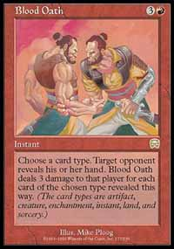
Not exactly exciting, but pretty effective with a 5-0 Fact or Fiction split

Play of the Week
More on Fact or Fiction 5-0 splits:
Several players wrote in mentioning the Blood Oath situation, where it pays to give an opponent all the cards and then kill them with a really large Blood Oath. However, that does not seem quite original enough anymore. Cole W sent in a Fact or Fiction 5-0 split that was more interesting:
"My friend was playing a b-r IBC Machine Head deck versus No-Mar. He attacked with Blazing Specter, in response his opponent cast Fact or Fictions with one card left in his hand, revealing 2 Undermine, 2 Exclude, and Repulse. He split the cards 5-0. No-Mar player took the pile of five, and discarded a Meddling Mage to the Specter. Then Machine Head player cast... Void for 3!"

Bad Play of the Week: One in a Million
Reported by Obi Wein:
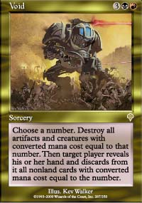
"I was playing in a booster draft at my local card shop. It was a small draft as there were roughly 8-12 people there. In round two I had lost the first game and won the second. Both of those games had gone by rather quickly. Game 3 was dragging on for quite some time with both myself and my opponent building up a good deal of creatures. My opponent was at 3 life and I should be able to go for the all out attack and win the next turn. Incidentally, I think 80% of my creatures on the board had a converted casting cost of 3. My opponent drew a card and smiled to himself. He tapped a black a red and 3 colorless into his pool. "Void for a million" he said. This of course confused me so I picked up the card and read it to make sure that somehow he doesn't have one that is written to sound like Pernicious Deed. After making sure my opponent had no idea what he was doing I asked him "You sure about that? Void for a million?" "Yes", he said, "Void for a million." He then proceeded to scoop up all his permanents and put them in his graveyard. He looked at me and said, "All your stuff is dead." "No it isn't", I said as I revealed my hand, "And I don't have anything in my hand with casting cost of 1 million either."
As always, please send good/bad plays, cool trivia questions, and other news to NEW ADDRESS: ashv80@hotmail.com.

